Template
Software Design Specification
Version 1.0

Revisions
Version | Primary Author(s) | Description of Version | Date Completed
Contents
1 Introduction 1
1.1 System Overview 1
1.2 Supporting Materials 1
1.3 Definitions and Acronyms 1
2 Design Considerations 2
2.1 Assumptions 2
2.2 Constraints 2
2.3 Goals and Guidelines 2
3 Architecture 3
3.1 Overview 3
3.2 Strategies 3
3.2.1 Technical Environment 3
3.2.2 Maintainability 3
3.2.3 Performance 3
3.3 Software Specification 3
3.4 Hardware Specification 3
4 System Level Design 5
4.1 Hierarchy Chart Of Components 5
4.2 Sequence Diagrams And Descriptions 5
5 Object Level Design 6
5.1 Component C1 6
5.1.1 Class D1 Of Component C1 6
5.2 Component C2 6
6 User Interface Design 7
6.1 User Interface Design Overview 7
6.2 User Interface Navigation Hierarchy 7
7 Requirements Traceability Matrix 8
8 Appendices 9

Introduction
<Provide an overview of the entire document, including the purpose, the scope and the intended audience of the document. Identify the product using any applicable names and/or version numbers.>
This document provides a template and description for the Handicapped Driver System, version 1.0. The scope herein encompasses the necessary hardware/software requirements, systems (subsystems, packages, classes), and different non-functional requirements imposed on the system. These items are elaborated in the sections below that explain the system design considerations, architecture, system level design, object level design, user interface design, traceability matrix, and appendices, respectively.

System Overview
<Provide a general description of the software product including its functionality and matters related to the overall system and its design.>
Handicapped Driver System, version 1.0, is a system that assists the handicapped students, faculty, and staff of UCO to reserve handicapped parking spaces on campus parking lots. This system will not only give the community an opportunity to reserve a spot but will also allow users to navigate to a parking spot, indicate they are in the spot, and leave the spot when they leave the parking space. The goal of this software is to improve the usability of UCO parking lots by making parking take less time and become more efficient. This system will be in a sense “owned” by the users because they will provide information to the system when they reserve, park, and leave a parking spot, although the database will clear all parking spots at midnight every day. As it can be seen, this is a client-server software system design.

Supporting Materials
<Provide references for any other pertinent documents such as related and/or companion documents, prerequisite documents and documents which provide background and/or context for this document.>
The System requirements specification (SRS) document is a precursor to this document. It provides the basis for which this project was created. The Microsoft Project is a supporting material that is utilized in this project for project management and work breakdown. For a further look into work breakdown, reference Appendix C.

Definitions and Acronyms
Term | Description
UCO | University of Central Oklahoma
iOS | Internetwork Operating System
GSM | Global System for Mobile
SMS | Short Message Service
IIS | Internet Information Services
JSON | JavaScript Object Notation
GUI | Graphical User Interface
SQL | Structured Query Language
CSS | Cascading Style Sheets
HTML | Hypertext Markup Language
SMTP | Simple Mail Transport Protocol
SSL | Secure Socket Layer
HTTPS | Using HTTP over SSL

Design Considerations

Assumptions
<Describe any assumptions or dependencies regarding the software and its use. These may concern such issues as related software or hardware, operating systems, end-user characteristics, and possible and/or probable changes in functionality.>
Our software depends on the performance of the server, internet connection, and user device in order to be operational. The software shall operate on the assumption that the server and UCO WIFI are operational. The server must be able to support the volume of users, which could increase the longer the software is available to the UCO community. The UCO WIFI or user device 3G or 4G capability will also be a dependency that the software will depend upon in order to be functional. In addition, the software operates with the assumption that UCO has parking lots that have handicapped parking spaces. If for whatever reason these were removed, the software would not be usable. The software shall operate under the assumption that UCO is still an operating institution, since the software genesis occurred to serve UCO faculty, staff, and students. This software operates on the assumption that only handicapped UCO faculty, staff, and students will park in the handicapped parking spaces. Individuals have only one account, so only one reservation will be made at any one time by a user. This software is designed under the assumption that mini-browsers are usable by Android, iOS, and desktop computers.

Constraints
<Describe any global limitations or constraints that have a significant impact on the design of the system's software. Such constraints may be imposed by any of the following (the list is not exhaustive): hardware or software environment, end-user environment, availability or volatility of resources, standards compliance, interoperability requirements, interface/protocol requirements, data repository and distribution requirements, security requirements (or other such regulations), memory and other capacity limitations, performance requirements, network communications, and other requirements described in the requirements specification.>
The software’s usefulness is directly tied to user input, which means that the user is the ultimate constraint on the software. Although all parking reservations are cleared and all parking spots are marked open at midnight every day, the users help maintain the accuracy of the system during the hours in which the system would be most frequently utilized. The software is further constrained by the volume of user traffic that the server can handle. The software has the physical constraint of the number of handicapped parking spaces that are available in each lot. Although there are many parking lots on the UCO campus that have handicapped parking spaces, not all of these lots are present on the software. The user is constrained to reserving parking spots in the lot(s) that are in the database.

Goals and Guidelines
<Describe any goals, guidelines, principles, or priorities which dominate or embody the design of the system's software. Such goals might be: the KISS principle ("Keep it simple stupid!"), emphasis on speed versus memory use, or working, looking, or "feeling" like an existing product. For each such goal or guideline, unless it is implicitly obvious, describe the reason for its desirability.>
This software has three goals in mind; namely usability, scalability, and accuracy. First, the software must be easily utilized by the end-user or this software serves no purpose. This software needs to make parking for handicapped individuals more efficient and painless, not more difficult. Secondly, the software needs to be scalable, meaning that it could be expanded to multiple parking lots or even multiple campuses. Thirdly, this software needs to be accurate so that users are able to depend on the data in the system. With these goals in mind, this software shall be designed to serve the handicapped community at UCO.

Architecture

Overview
< Determine what parts of the application software will be assigned to what hardware. Describe any design decisions and/or strategies that affect the overall organization of the system and its higher-level structures. These strategies should provide insight into the key abstractions and mechanisms used in the system architecture. Describe the reasoning em-ployed for each decision and/or strategy (possibly referring to previously stated design goals and principles) and how any design goals or priorities were balanced or traded-off.>

Strategies

Technical Environment
<Special hardware, software, and network requirements imposed by business requirements>
Business requirements do not necessitate any special hardware or software beyond a GSM modem or SMS messaging service to facilitate timely reporting of reservation usage in the way of arrivals and departures. General system hardware and software needs are listed in sections 3.2.3 and 3.2.4.

Maintainability
<Expected business changes to which the system should be able to adapt>
In order to be maintainable the system could be switched to a larger server. SMS might necessitate extra GSM modems. Any unforeseen connectivity or authentication issues shall be handled on a case-by-case basis.

Performance
<The time within which the system must perform its functions; the total and peak number of users and volume of data expected; the extent to which the system will be available to the users and the permissible failure rate due to errors>
Any request from the browser has to respond to the user within 100 seconds or it shall result in a time-out. The expected number of users is expected to be less than 1000. The system is expected to handle 10 MB per year.

Software Specification
<Determine software needs, such as OS, development IDE, JDK version, other SDK version, etc. >
The server shall be a Windows Server 2008 or later, which includes Internet Information Services (IIS) and .NET framework, 4.0 or later. The software shall be developed in Visual Studio, Web Storm (Jet Brains), and SQL Server Express.

Hardware Specification
- Clients
  - Mobile devices, desktop systems, laptops
- Servers
  - File/application server connected to the internet capable of running:
    - Data service (SQL Server)
    - Web service (IIS)
  - Accessible by many users
- Network
  - GSM modem or online service for sending SMS messages
  - SSL that will need to have a registered certificate (Verisign)

System Level Design
<Provide a high-level overview of how the functionality and responsibilities of the system were partitioned and then assigned to subsystems or components. Don't go into too much detail about the individual components themselves (there is a subsequent section for detailed component descriptions). The main purpose here is to gain a general understanding of how and why the system was decomposed, and how the individual parts work together to provide the desired functionality.>
Per the Software Requirements Specification (SRS), the Handicapped Driver design is required to “provide user/driver interaction via web browsers on both Android and iOS smart devices and Windows and OSx operating systems” (SRS 1.1); therefore, a presentation layer (GUI) was designed as an independent section and partitioned accordingly. Additionally, the system must store information related to parking lots/spaces, registered drivers and ongoing reservations made by drivers for the spaces. Therefore, an independent data layer (database) was also designed and partitioned. The core of the system remains as its own layer and contains both business logic and components to interact with the aforementioned presentation and data layers. The core also contains adapters as interfaces that implement features facilitated by external systems such as communication (SMS and Email), road navigation (Google Maps), and the scheduled “cleanup” of internal data. Overall, the Handicapped Driver System is architected as a multi-tier software solution within a web-based client-server paradigm.

Hierarchy Chart of Components
<Describe the major responsibilities that the software must undertake and the various roles that the system (or portions of the system) must play. Describe how the system was broken down into its components/subsystems (identifying each top-level component/subsystem and the roles/responsibilities assigned to it). Describe how the higher-level components collaborate with each other in order to achieve the required results. Don't forget to provide some sort of rationale for choosing this particular decomposition of the system (perhaps discussing other proposed decompositions and why they were rejected). >
As shown below (fig 4.1), the system is broken down by design into four major packages: data, presentation, core logic and external systems. The data layer contains the underlying storage implemented in normalized database form plus services that execute SQL instructions for data operations (select/insert/update/delete); this is a common software industry approach to data handling and utilizes Structured Query Language (SQL), another industry standard. The presentation layer is designed for execution within any browser that can render HTML and execute JavaScript. As both mobile devices (Android, iPhone) and desktop systems (Windows, iOS, Linux) employ such browsers, this approach provides a common “look and feel” for users and allows minimal code and GUI design duplication for developers. Access to features provided by external systems are handled by adapters used to implement inter-system operations transparently to the core system. Business logic for the reservations, as well as, the adapters, and a bridge to the data layer are all designed into the core system; a façade, or “focal point” for communication with the presentation layer components is additionally integrated into the system core. High-level system architecture was driven first by the requirement that user interaction was to occur via a multitude of disparate devices and operating systems, thus leading to the client-server model using a web browser client. Further divisions were made to separate the data access component for scalability (i.e. MS Access to Oracle), and to accommodate and group external system dependencies together. The result of multiple divisions is an overall multi-tiered architecture.

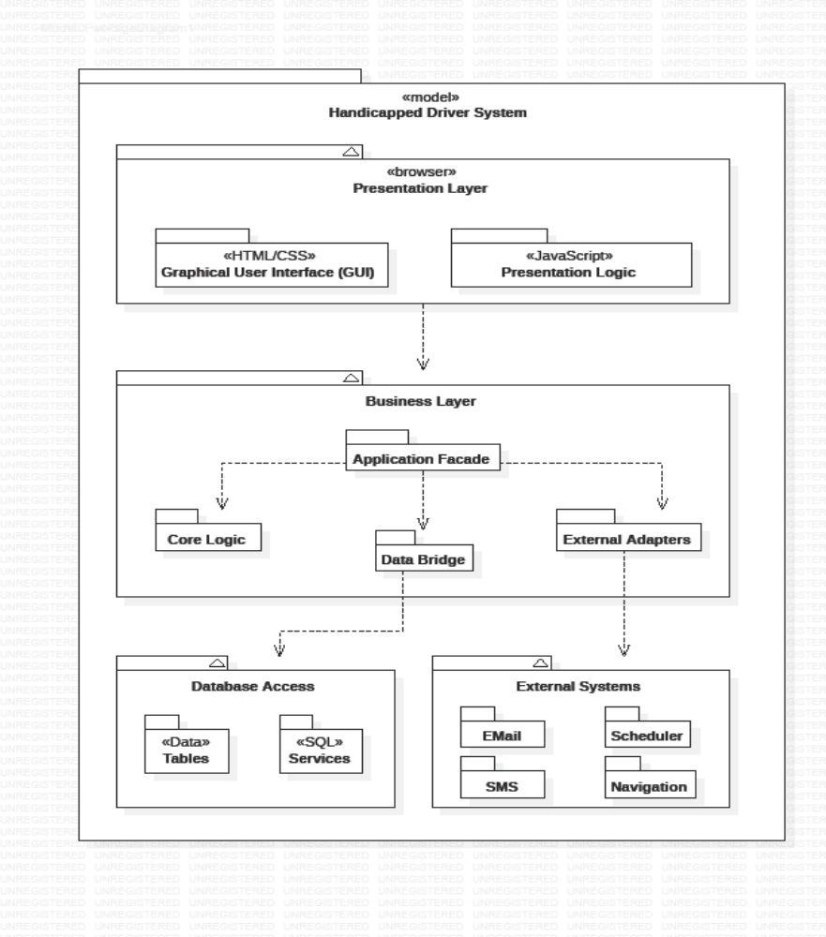
Figure 4.1 – Package Diagram

Sequence Diagrams and Descriptions
<Describe the interaction behavior between classes. The typical sequence diagram will depict some or all of the behavior described in a use case. Therefore, sequence diagrams serve as an intermediary between use cases and classes. As a result, classes can be traced back to the requirements. >
The system requires a simple login sequence before any interaction with the rest of the system is allowed (minus the New User feature). Depicted below is the initiation from the Login page within the GUI. The user’s login name and password are collected and passed to the Application Façade, through to the Driver class of the core system for any necessary pre-processing. The Driver class then verifies that the collected information matches that stored in the database by searching (through the DataBridge) for a match. A success or failure token is then sent back through each initiating class until the user is either logged in or asked to “try again”.

Figure 4.2a – User/Driver Login
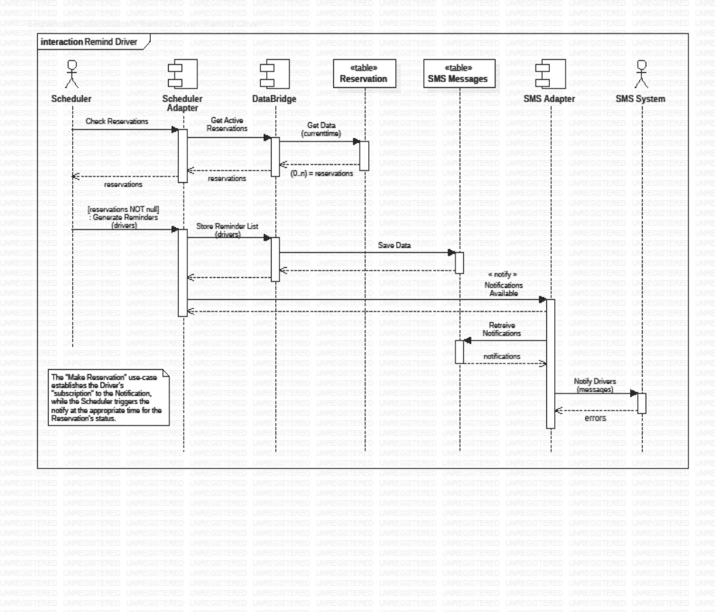
Figure 4.2b – Remind Driver

Figure 4.2c – Make Reservation

Figure 4.2d – Use Reservation (Park, Leave or Cancel)

Object Level Design
<Provide more detailed discussion in a subsection/component of the component hierarchy section 4.1. If necessary, describe how the component was further divided into subcomponents, and the relationships and interactions between the subcomponents (similar to what was done for top-level components in Section 4.1).>

Component C1
<Provide and describe a class hierarchy diagram that depicts the set of classes for Compo-nent C1>

Class D1 Of Component C1
<Provide a class diagram for Class D1 of Component C1. Provide a description of any relevant characteristics of Class D1.>

Component C2

User Interface Design

User Interface Design Overview
<Provide a high-level description of the user interface for this software application. Describe any systems requirements (e.g., performance or usability) associated with all of the user interfaces. >
A client-server-based software must have a user interface. Therefore, it is one of the main elements in any software system. This system is no different. The presentation layer of the system utilizes HTML5/CSS3 as the GUI and JavaScript and as it’s presentation logic. The interface contains of a series of responsive pages that the user can interact. Initially, the user will be taken to a login screen where the user can enter their credentials to login. Once successfully logged in, the user will be directed to the home page/landing page where there are four options. Those options include: update user’s password, view available spaces, view their reservation, and message driver. Note that the purpose of message driver is that it will notify the driver who have taken a spot reserved for another driver. Also, to prevent aggressive communication between drivers, the system will automatically generate messages.
The interface will run on any web browsers which supports HTML5/CSS3. Depending on network speed, the web pages should load within the default time of a web requests.

User Interface Navigation Hierarchy
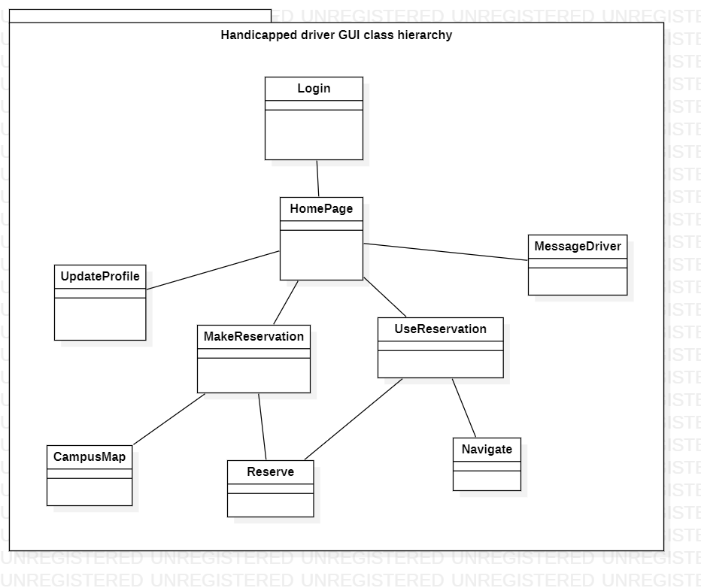
The package diagram above represents the navigation path of the user interface. Initially, when the user login, the page directs to the home page. In the home page, the user has four options, they are update profile, make reservation, show reservation, and message driver. The make reservation page has two GUI, campus map and reserve spot. By clicking “Reserve” in make reservation page, the user will be taken to show reservation page. The user can also reach the show reservation page by clicking “My reservation” button from the home page. The show reservation page allows the user “Navigate” to their reserved spot and mark that spot as “Occupy”, “Leave” or “Cancel”.

User Interfaces System Requirements

Login

The application starts with the login page (screen shot of login page can be seen in appendix B “picture 8.1.1.1”). The user will enter his/her user name for validation purposes and click the “LOGIN” button to proceed to the home page.

Requirements
The user does not have to enter their full UCO email extension. The text field already has the extension to its right. If the user does not exist in the system, the system will generate a temporary password and an email will be send to the user specified address.

Home page
After the user successfully login, the user will be taken to the home page (displayed in the appendix B “picture 8.1.1.2”). Here the user has four options to choose from.

Requirements
As mentioned in the requirements for login page, first time users will receive a temporary password via email. The user cannot experience the full capability of the system without resetting his/her password. Every button will be disabled except the “Update profile”. This is to make sure that the user has entered all the necessary information.

Update profile
The user can update their profile by clicking the Update profile button in the homepage. Here the user will be prompted for some inputs. (screen shot in appendix B “picture 8.1.1.3”)

Requirements

It is necessary to fill out all the fields in this page.

View available
This page allows the user to do the following actions:
- View campus map
Here the user can view the campus map by clicking “Campus map” button in the view available page. The user will be taken to a page owned by UCO, which displays an image of the entire campus in .pdf format (Reference can be found under section 8.1.2 appendix B “ref 8.1.2.1”).
- Make reservation
Here the user can reserve their spot by clicking “Reserve spot” button.

Requirements:
The user must select a lot from the dropdown next to “Reserve spot” button. Otherwise, a spot won’t be reserved, and nothing will be saved to the database.
Note: - Screenshot of this page can be seen in appendix B “picture 8.1.1.4”.

Show reservation
Once the user clicks the “Reserve spot button in View available page”, they will be directed to the show reservation page. Here the user can navigate to the spot by clicking “Navigate” which will open google maps in another page with the specified location. After the use has reached their destination the user can mark the spot as “Occupy”. When the user decides to leave, he/she can click “Leave” button to free that spot. Also, if the user decided to change his/her mind and want to cancel the reservation, they can do that by clicking “Cancel” button. (Screenshot in appendix B “picture 8.1.1.5”)
If the user wishes to go to the “Show reservation” directly from the home page, the user can do that by clicking “My reservation” button in the “Home page”. (appendix B “picture 8.1.1.2)

Requirements
This page uses Google maps API version 3.36 or above. (Reference: “ref 8.1.2.2”)

Message Driver
The system has a capability to message another, who is parked in someone else’s spot. The user can do this by clicking “Message driver” button in the home page. Here the user will select the vehicle’s registration state from a dropdown and enter the registration number. The system will generate a message and send it to the driver. (Screenshot in appendix B “picture 8.1.1.6”)

Requirements
In order to message a driver that driver must exist in the database.

Requirements Traceability Matrix

Requirements | # | GUI | JavaScript | Core Logic | SQL Tables | SQL Services | Email | SMS | Scheduler | Navigation
Client/server architecture | 1 | X | X | X | X | X | X | X | X | X
Client will handle UI | 2 | X | X
Server will handle data storage and business logic execution | 3 |  |  | X | X
Lookup campus parking map | 4 | X | X
Identify reserved parking spots for people with disabilities | 5 | X | X |  | X | X
Search for a parking lot | 6 | X | X |  | X | X
Search for available and reserved parking spaces | 7 | X | X | X | X | X
Get directions to a particular parking lot | 8 | X | X |  | X | X |  |  |  | X
Navigate to the available and reserved parking spaces | 9 | X | X | X | X | X |  |  |  | X
Update the status of a parking space hold/available/unavailable | 10 | X | X | X | X | X |  |  | X
Implementation of the client system is on mobile OS or web browser | 11 | X | X
Reminds user of status reservation changes | 12 |  |  | X | X | X |  | X | X
User creation and authentication | 13 | X | X | X | X | X | X

Appendices

Appendix A: C++ Coding Convention

C++ Version
Currently, code should target C++17, i.e., should not use C++2x features. Consider portability to other environments before using features from C++14 and C++17 in your project.

Header Files
In general, every .cpp file should have an associated .h file. There are some common exceptions, such as unit tests and small .cpp files containing just a main() function.

Forward Declarations
Avoid using forward declarations where possible. Instead, #include the headers you need.

Names and Order of Includes
Include headers in the following order: Related header, C system headers, C++ standard library headers, other libraries' headers, your project's headers.
All of a project's header files should be listed as descendants of the project's source directory without use of UNIX directory aliases . (the current directory) or .. (the parent directory). For example, google-awesome-project/src/base/logging.h should be included as:
#include "base/logging.h"
In dir/foo.cpp or dir/foo_test.cpp, whose main purpose is to implement or test the stuff in dir2/foo2.h, order your includes as follows:
- dir2/foo2.h.
- A blank line
- C system headers (more precisely: headers in angle brackets with the .h extension), e.g. <unistd.h>, <stdlib.h>.
- A blank line
- C++ standard library headers (without file extension), e.g. <algorithm>, <cstddef>.
- A blank line
- Other libraries' .h files.
- Your project's .h files.
Separate each non-empty group with one blank line.

Scoping

Static Variables
When definitions in a .cpp file do not need to be referenced outside that file, declare them static. Do not use either of these constructs in .h files.
Functions and variables can also be given internal linkage by declaring them static. This means that anything you're declaring can't be accessed from another file. If a different file declares something with the same name, then the two entities are completely independent.
Use of internal linkage in .cpp files is encouraged for all code that does not need to be referenced elsewhere. Do not use internal linkage in .h files.

Nonmember, Static Member, and Global Functions
Prefer placing nonmember functions in a namespace; use completely global functions rarely. Do not use a class simply to group static functions. Static methods of a class should generally be closely related to instances of the class or the class's static data.
Nonmember and static member functions can be useful in some situations. Putting nonmember functions in a namespace avoids polluting the global namespace.
Nonmember and static member functions may make more sense as members of a new class, especially if they access external resources or have significant dependencies.
Sometimes it is useful to define a function not bound to a class instance. Such a function can be either a static member or a nonmember function. Nonmember functions should not depend on external variables, and should nearly always exist in a namespace. Do not create classes only to group static member functions; this is no different than just giving the function names a common prefix, and such grouping is usually unnecessary anyway.
If you define a nonmember function and it is only needed in its .cpp file, use internal linkage to limit its scope.

Local Variables
Place a function's variables in the narrowest scope possible, and initialize variables in the declaration.
C++ allows you to declare variables anywhere in a function. We encourage you to declare them in as local a scope as possible, and as close to the first use as possible. This makes it easier for the reader to find the declaration and see what type the variable is and what it was initialized to. In particular, initialization should be used instead of declaration and assignment, e.g.:
int i;
i = f(); // Bad -- initialization separate from declaration.
int j = g(); // Good -- declaration has initialization.
std::vector<int> v;
v.push_back(1); // Prefer initializing using brace initialization.
v.push_back(2);
std::vector<int> v = {1, 2}; // Good -- v starts initialized.
Variables needed for if, while and for statements should normally be declared within those statements, so that such variables are confined to those scopes. E.g.:
while (const char* p = strchr(str, '/')) str = p + 1;
There is one caveat: if the variable is an object, its constructor is invoked every time it enters scope and is created, and its destructor is invoked every time it goes out of scope.
// Inefficient implementation:
for (int i = 0; i < 1000000; ++i) {
Foo f; // My ctor and dtor get called 1000000 times each.
f.DoSomething(i);
}
It may be more efficient to declare such a variable used in a loop outside that loop:
Foo f; // My ctor and dtor get called once each.
for (int i = 0; i < 1000000; ++i) {
f.DoSomething(i);
}

Static and Global Variables
Objects with static storage duration are forbidden unless they are trivially destructible. Informally this means that the destructor does not do anything, even taking member and base destructors into account. More formally it means that the type has no user-defined or virtual destructor and that all bases and non-static members are trivially destructible. Static function-local variables may use dynamic initialization.

Decision on initialization
Initialization is a more complex topic. This is because we must not only consider whether class constructors execute, but we must also consider the evaluation of the initializer:
int n = 5; // fine
int m = f(); // ? (depends on f)
Foo x; // ? (depends on Foo::Foo)
Bar y = g(); // ? (depends on g and on Bar::Bar)
All but the first statement expose us to indeterminate initialization ordering.
The concept we are looking for is called constant initialization in the formal language of the C++ standard. It means that the initializing expression is a constant expression, and if the object is initialized by a constructor call, then the constructor must be specified as constexpr, too:
struct Foo { constexpr Foo(int) {} };

int n = 5; // fine, 5 is a constant expression
Foo x(2); // fine, 2 is a constant expression and the chosen constructor is constexpr
Foo a[] = { Foo(1), Foo(2), Foo(3) }; // fine
Constant initialization is always allowed. Constant initialization of static storage duration variables should be marked with constexpr or where possible the ABSL_CONST_INIT attribute. Any non-local static storage duration variable that is not so marked should be presumed to have dynamic initialization, and reviewed very carefully.
By contrast, the following initializations are problematic:
// Some declarations used below.
time_t time(time_t*); // not constexpr!
int f(); // not constexpr!
struct Bar { Bar() {} };

// Problematic initializations.
time_t m = time(nullptr); // initializing expression not a constant expression
Foo y(f()); // ditto
Bar b; // chosen constructor Bar::Bar() not constexpr
Dynamic initialization of nonlocal variables is discouraged, and in general it is forbidden. However, we do permit it if no aspect of the program depends on the sequencing of this initialization with respect to all other initializations. Under those restrictions, the ordering of the initialization does not make an observable difference. For example:
int p = getpid(); // allowed, as long as no other static variable
// uses p in its own initialization
Dynamic initialization of static local variables is allowed (and common).

Classes
Classes are the fundamental unit of code in C++. Naturally, we use them extensively. This section lists the main dos and don'ts you should follow when writing a class.

Doing Work in Constructors
Avoid virtual method calls in constructors, and avoid initialization that can fail if you can't signal an error.
It is possible to perform arbitrary initialization in the body of the constructor.
- No need to worry about whether the class has been initialized or not.
- Objects that are fully initialized by constructor call can be const and may also be easier to use with standard containers or algorithms.
- If the work calls virtual functions, these calls will not get dispatched to the subclass implementations. Future modification to your class can quietly introduce this problem even if your class is not currently subclassed, causing much confusion.
- There is no easy way for constructors to signal errors, short of crashing the program (not always appropriate) or using exceptions.
- If the work fails, we now have an object whose initialization code failed, so it may be an unusual state requiring a bool IsValid() state checking mechanism (or similar) which is easy to forget to call.
- You cannot take the address of a constructor, so whatever work is done in the constructor cannot easily be handed off to, for example, another thread.
Constructors should never call virtual functions. If appropriate for your code, terminating the program may be an appropriate error handling response. Otherwise, consider a factory function or Init() method. Avoid Init() methods on objects with no other states that affect which public methods may be called (semi-constructed objects of this form are particularly hard to work with correctly).

Structs vs. Classes
Use a struct only for passive objects that carry data; everything else is a class.
The struct and class keywords behave almost identically in C++. We add our own semantic meanings to each keyword, so you should use the appropriate keyword for the data-type you're defining.
structs should be used for passive objects that carry data, and may have associated constants, but lack any functionality other than access/setting the data members. All fields must be public, and accessed directly rather than through getter/setter methods. The struct must not have invariants that imply relationships between different fields, since direct user access to those fields may break those invariants. Methods should not provide behavior but should only be used to set up the data members, e.g., constructor, destructor, Initialize(), Reset().
If more functionality or invariants are required, a class is more appropriate. If in doubt, make it a class.
For consistency with STL, you can use struct instead of class for stateless types, such as traits, template metafunctions, and some functors.
Note that member variables in structs and classes have different naming rules.

Inheritance
Composition is often more appropriate than inheritance. When using inheritance, make it public.
When a sub-class inherits from a base class, it includes the definitions of all the data and operations that the base class defines. "Interface inheritance" is inheritance from a pure abstract base class (one with no state or defined methods); all other inheritance is "implementation inheritance".
Implementation inheritance reduces code size by re-using the base class code as it specializes an existing type. Because inheritance is a compile-time declaration, you and the compiler can understand the operation and detect errors. Interface inheritance can be used to programmatically enforce that a class expose a particular API. Again, the compiler can detect errors, in this case, when a class does not define a necessary method of the API.
For implementation inheritance, because the code implementing a sub-class is spread between the base and the sub-class, it can be more difficult to understand an implementation. The sub-class cannot override functions that are not virtual, so the sub-class cannot change implementation.
Multiple inheritance is especially problematic, because it often imposes a higher performance overhead (in fact, the performance drop from single inheritance to multiple inheritance can often be greater than the performance drop from ordinary to virtual dispatch), and because it risks leading to "diamond" inheritance patterns, which are prone to ambiguity, confusion, and outright bugs.
All inheritance should be public. If you want to do private inheritance, you should be including an instance of the base class as a member instead.
Do not overuse implementation inheritance. Composition is often more appropriate. Try to restrict use of inheritance to the "is-a" case: Bar subclasses Foo if it can reasonably be said that Bar "is a kind of" Foo.
Limit the use of protected to those member functions that might need to be accessed from subclasses. Note that data members should be private.
Explicitly annotate overrides of virtual functions or virtual destructors with exactly one of an override or (less frequently) final specifier. Do not use virtual when declaring an override. Rationale: A function or destructor marked override or final that is not an override of a base class virtual function will not compile, and this helps catch common errors. The specifiers serve as documentation; if no specifier is present, the reader has to check all ancestors of the class in question to determine if the function or destructor is virtual or not.
Multiple inheritance is permitted, but multiple implementation inheritance is strongly discouraged.

Access Control
Make classes' data members private, unless they are constants. This simplifies reasoning about invariants, at the cost of some easy boilerplate in the form of accessors (usually const) if necessary.
For technical reasons, we allow data members of a test fixture class in a cpp file to be protected when using Google Test).

Declaration Order
Group similar declarations together, placing private parts earlier.
A class definition should usually start with a private: section, followed by protected:, then public: . Omit sections that would be empty.

Functions

Output Parameters
The output of a C++ function is naturally provided via a return value and sometimes via output parameters.
Prefer using return values over output parameters: they improve readability, and often provide the same or better performance. If output-only parameters are used, they should appear after input parameters.
Parameters are either input to the function, output from the function, or both. Input parameters are usually values or const references, while output and input/output parameters will be pointers to non-const.
When ordering function parameters, put all input-only parameters before any output parameters. In particular, do not add new parameters to the end of the function just because they are new; place new input-only parameters before the output parameters.
This is not a hard-and-fast rule. Parameters that are both input and output (often classes/structs) muddy the waters, and, as always, consistency with related functions may require you to bend the rule.

Write Short Functions
Prefer small and focused functions.
We recognize that long functions are sometimes appropriate, so no hard limit is placed on functions length. If a function exceeds about 40 lines, think about whether it can be broken up without harming the structure of the program.

Reference Arguments
All parameters passed by lvalue reference must be labeled const.
In C, if a function needs to modify a variable, the parameter must use a pointer, eg int foo(int *pval). In C++, the function can alternatively declare a reference parameter: int foo(int &val).
Defining a parameter as reference avoids ugly code like (*pval)++. Necessary for some applications like copy constructors. Makes it clear, unlike with pointers, that a null pointer is not a possible value.
References can be confusing, as they have value syntax but pointer semantics.
Within function parameter lists all references must be const:
void Foo(const std::string &in, std::string *out);
In fact it is a very strong convention in Google code that input arguments are values or const references while output arguments are pointers. Input parameters may be const pointers, but we never allow non-const reference parameters except when required by convention, e.g., swap().
However, there are some instances where using const T* is preferable to const T& for input parameters. For example:
- You want to pass in a null pointer.
- The function saves a pointer or reference to the input.
Remember that most of the time input parameters are going to be specified as const T&. Using const T* instead communicates to the reader that the input is somehow treated differently. So if you choose const T* rather than const T&, do so for a concrete reason; otherwise it will likely confuse readers by making them look for an explanation that doesn't exist.

Default Arguments
Default arguments are allowed on non-virtual functions when the default is guaranteed to always have the same value.

Other C++ Features

Exceptions
We will utilize exceptions to test code. These exceptions shall be used primarily to make sure that the correct type is passed to a function call.

Casting
Use C++-style casts like static_cast<float>(double_value), or brace initialization for conversion of arithmetic types like int64 y = int64{1} << 42. Do not use cast formats like int y = (int)x or int y = int(x) (but the latter is okay when invoking a constructor of a class type).
C++ introduced a different cast system from C that distinguishes the types of cast operations.
The problem with C casts is the ambiguity of the operation; sometimes you are doing a conversion (e.g., (int)3.5) and sometimes you are doing a cast (e.g., (int)"hello"). Brace initialization and C++ casts can often help avoid this ambiguity. Additionally, C++ casts are more visible when searching for them.

Use of const
In APIs, use const whenever it makes sense.
Declared variables and parameters can be preceded by the keyword const to indicate the variables are not changed (e.g., const int foo). Class functions can have the const qualifier to indicate the function does not change the state of the class member variables (e.g., class Foo { int Bar(char c) const; };).
Easier for people to understand how variables are being used. Allows the compiler to do better type checking, and, conceivably, generate better code. Helps people convince themselves of program correctness because they know the functions they call are limited in how they can modify your variables. Helps people know what functions are safe to use without locks in multi-threaded programs.
const is viral: if you pass a const variable to a function, that function must have const in its prototype (or the variable will need a const_cast). This can be a particular problem when calling library functions.
We strongly recommend using const in APIs (i.e. on function parameters, methods, and non-local variables) wherever it is meaningful and accurate. This provides consistent, mostly compiler-verified documentation of what objects an operation can mutate. Having a consistent and reliable way to distinguish reads from writes is critical to writing thread-safe code, and is useful in many other contexts as well. In particular:
- If a function guarantees that it will not modify an argument passed by reference or by pointer, the corresponding function parameter should be a reference-to-const (const T&) or pointer-to-const (const T*), respectively.
- For a function parameter passed by value, const has no effect on the caller, thus is not recommended in function declarations.
- Declare methods to be const unless they alter the logical state of the object (or enable the user to modify that state, e.g. by returning a non-const reference, but that's rare), or they can't safely be invoked concurrently.
Using const on local variables is neither encouraged nor discouraged.
All of a class's const operations should be safe to invoke concurrently with each other. If that's not feasible, the class must be clearly documented as "thread-unsafe".
The const keyword should be placed after the type name when a constant is declared.

0 and nullptr/NULL
Use nullptr for pointers, and '\0' for chars (and not the 0 literal).
For pointers (address values), use nullptr, as this provides type-safety.
For C++03 projects, prefer NULL to 0. While the values are equivalent, NULL looks more like a pointer to the reader, and some C++ compilers provide special definitions of NULL which enable them to give useful warnings. Never use NULL for numeric (integer or floating-point) values.
Use '\0' for the null character. Using the correct type makes the code more readable.

Naming
The most important consistency rules are those that govern naming. The style of a name immediately informs us what sort of thing the named entity is: a type, a variable, a function, a constant, a macro, etc., without requiring us to search for the declaration of that entity. The pattern-matching engine in our brains relies a great deal on these naming rules.
Naming rules are pretty arbitrary, but we feel that consistency is more important than individual preferences in this area, so regardless of whether you find them sensible or not, the rules are the rules.

General Naming Rules
Optimize for readability using names that would be clear even to people on a different team.
Use names that describe the purpose or intent of the object. Do not worry about saving horizontal space as it is far more important to make your code immediately understandable by a new reader. Minimize the use of abbreviations that would likely be unknown to someone outside your project (especially acronyms and initialisms). Do not abbreviate by deleting letters within a word. As a rule of thumb, an abbreviation is probably OK if it's listed in Wikipedia. Generally speaking, descriptiveness should be proportional to the name's scope of visibility. For example, n may be a fine name within a 5-line function, but within the scope of a class, it's likely too vague.
class MyClass {
public:
int CountFooErrors(const std::vector<Foo>& foos) {
int n = 0; // Clear meaning given limited scope and context
for (const auto& foo : foos) {
...
++n;
}
return n;
}
void DoSomethingImportant() {
std::string fqdn = ...; // Well-known abbreviation for Fully Qualified Domain Name
}
private:
const int kMaxAllowedConnections = ...; // Clear meaning within context
};
class MyClass {
public:
int CountFooErrors(const std::vector<Foo>& foos) {
int total_number_of_foo_errors = 0; // Overly verbose given limited scope and context
for (int foo_index = 0; foo_index < foos.size(); ++foo_index) { // Use idiomatic `i`
...
++total_number_of_foo_errors;
}
return total_number_of_foo_errors;
}
void DoSomethingImportant() {
int cstmr_id = ...; // Deletes internal letters
}
private:
const int kNum = ...; // Unclear meaning within broad scope
};
Note that certain universally-known abbreviations are OK, such as i for an iteration variable and T for a template parameter.
For the purposes of the naming rules below, a "word" is anything that you would write in English without internal spaces. This includes abbreviations and acronyms; e.g., for "camel case" or "Pascal case," in which the first letter of each word is capitalized, use a name like StartRpc(), not StartRPC().
Template parameters should follow the naming style for their category: type template parameters should follow the rules for type names, and non-type template parameters should follow the rules for variable names.

File Names
Filenames should be all lowercase and can include underscores (_) or dashes (-). Follow the convention that your project uses. If there is no consistent local pattern to follow, prefer "_".
Examples of acceptable file names:
- my_useful_classcpp
- my-useful-classcpp
- myusefulclasscpp
- myusefulclass_testcpp // _unittest and _regtest are deprecated.
C++ files should end in cpp and header files should end in .h. Files that rely on being textually included at specific points should end in .inc (see also the section on self-contained headers).
Do not use filenames that already exist in /usr/include, such as db.h.
In general, make your filenames very specific. For example, use http_server_logs.h rather than logs.h. A very common case is to have a pair of files called, e.g., foo_bar.h and foo_barcpp, defining a class called FooBar.

Type Names
Type names start with a capital letter and have a capital letter for each new word, with no underscores: MyExcitingClass, MyExcitingEnum.
The names of all types — classes, structs, type aliases, enums, and type template parameters — have the same naming convention. Type names should start with a capital letter and have a capital letter for each new word. No underscores. For example:
// classes and structs
class UrlTable { ...
class UrlTableTester { ...
struct UrlTableProperties { ...

// typedefs
typedef hash_map<UrlTableProperties *, std::string> PropertiesMap;

// using aliases
using PropertiesMap = hash_map<UrlTableProperties *, std::string>;

// enums
enum UrlTableErrors { ...

Variable Names
The names of variables (including function parameters) and data members are all lowercase, with underscores between words.

Constant Names
Variables declared const, and whose value is fixed for the duration of the program, are named with a leading "k" followed by mixed case. Underscores can be used as separators in the rare cases where capitalization cannot be used for separation. For example:
const int kDaysInAWeek = 7;
const int kAndroid8_0_0 = 24; // Android 8.0.0
All such variables with static storage duration (i.e. statics and globals, see Storage Duration for details) should be named this way. This convention is optional for variables of other storage classes, e.g. automatic variables, otherwise the usual variable naming rules apply.

Function Names
Regular functions have mixed case; accessors and mutators may be named like variables.
Ordinarily, functions should start with a capital letter and have a capital letter for each new word.
AddTableEntry()
DeleteUrl()
OpenFileOrDie()
(The same naming rule applies to class- and namespace-scope constants that are exposed as part of an API and that are intended to look like functions, because the fact that they're objects rather than functions is an unimportant implementation detail.)
Accessors and mutators (get and set functions) may be named like variables. These often correspond to actual member variables, but this is not required. For example, int count() and void set_count(int count).

Enumerator Names
Enumerators (for both scoped and unscoped enums) should be named either like constants or like macros: either kEnumName or ENUM_NAME.
Preferably, the individual enumerators should be named like constants. However, it is also acceptable to name them like macros. The enumeration name, UrlTableErrors (and AlternateUrlTableErrors), is a type, and therefore mixed case.
enum UrlTableErrors {
kOk = 0,
kErrorOutOfMemory,
kErrorMalformedInput,
};
enum AlternateUrlTableErrors {
OK = 0,
OUT_OF_MEMORY = 1,
MALFORMED_INPUT = 2,
};

Exceptions to Naming Rules
If you are naming something that is analogous to an existing C or C++ entity then you can follow the existing naming convention scheme.
bigopen()
function name, follows form of open()
uint
typedef
bigpos
struct or class, follows form of pos
sparse_hash_map
STL-like entity; follows STL naming conventions
LONGLONG_MAX
a constant, as in INT_MAX

Comments
Comments are absolutely vital to keeping our code readable. The following rules describe what you should comment and where. But remember: while comments are very important, the best code is self-documenting. Giving sensible names to types and variables is much better than using obscure names that you must then explain through comments.
When writing your comments, write for your audience: the next contributor who will need to understand your code. Be generous — the next one may be you!

Comment Style
Use either the // or /* */ syntax, as long as you are consistent.
You can use either the // or the /* */ syntax; however, // is much more common. Be consistent with how you comment and what style you use where.

File Contents
If a .h declares multiple abstractions, the file-level comment should broadly describe the contents of the file, and how the abstractions are related. A 1 or 2 sentence file-level comment may be sufficient. The detailed documentation about individual abstractions belongs with those abstractions, not at the file level.
Do not duplicate comments in both the .h and the cpp. Duplicated comments diverge.

Function Declarations
Almost every function declaration should have comments immediately preceding it that describe what the function does and how to use it. These comments may be omitted only if the function is simple and obvious (e.g. simple accessors for obvious properties of the class). These comments should open with descriptive verbs in the indicative mood ("Opens the file") rather than verbs in the imperative ("Open the file"). The comment describes the function; it does not tell the function what to do. In general, these comments do not describe how the function performs its task. Instead, that should be left to comments in the function definition.
Types of things to mention in comments at the function declaration:
- What the inputs and outputs are.
- For class member functions: whether the object remembers reference arguments beyond the duration of the method call, and whether it will free them or not.
- If the function allocates memory that the caller must free.
- Whether any of the arguments can be a null pointer.
- If there are any performance implications of how a function is used.
- If the function is re-entrant. What are its synchronization assumptions?
Here is an example:
// Returns an iterator for this table. It is the client's
// responsibility to delete the iterator when it is done with it,
// and it must not use the iterator once the GargantuanTable object
// on which the iterator was created has been deleted.
//
// The iterator is initially positioned at the beginning of the table.
//
// This method is equivalent to:
// Iterator* iter = table->NewIterator();
// iter->Seek("");
// return iter;
// If you are going to immediately seek to another place in the
// returned iterator, it will be faster to use NewIterator()
// and avoid the extra seek.
Iterator* GetIterator() const;
However, do not be unnecessarily verbose or state the completely obvious.
When documenting function overrides, focus on the specifics of the override itself, rather than repeating the comment from the overridden function. In many of these cases, the override needs no additional documentation and thus no comment is required.
When commenting constructors and destructors, remember that the person reading your code knows what constructors and destructors are for, so comments that just say something like "destroys this object" are not useful. Document what constructors do with their arguments (for example, if they take ownership of pointers), and what cleanup the destructor does. If this is trivial, just skip the comment. It is quite common for destructors not to have a header comment.

Function Definitions
If there is anything tricky about how a function does its job, the function definition should have an explanatory comment. For example, in the definition comment you might describe any coding tricks you use, give an overview of the steps you go through, or explain why you chose to implement the function in the way you did rather than using a viable alternative. For instance, you might mention why it must acquire a lock for the first half of the function but why it is not needed for the second half.
Note you should not just repeat the comments given with the function declaration, in the .h file or wherever. It's okay to recapitulate briefly what the function does, but the focus of the comments should be on how it does it.

Class Data Members
The purpose of each class data member (also called an instance variable or member variable) must be clear. If there are any invariants (special values, relationships between members, lifetime requirements) not clearly expressed by the type and name, they must be commented. However, if the type and name suffice (int num_events_;), no comment is needed.
In particular, add comments to describe the existence and meaning of sentinel values, such as nullptr or -1, when they are not obvious. For example:
private:
// Used to bounds-check table accesses. -1 means
// that we don't yet know how many entries the table has.
int num_total_entries_;

Global Variables
All global variables should have a comment describing what they are, what they are used for, and (if unclear) why it needs to be global. For example:
// The total number of tests cases that we run through in this regression test.
const int kNumTestCases = 6;

Punctuation, Spelling, and Grammar
Pay attention to punctuation, spelling, and grammar; it is easier to read well-written comments than badly written ones.
Comments should be as readable as narrative text, with proper capitalization and punctuation. In many cases, complete sentences are more readable than sentence fragments. Shorter comments, such as comments at the end of a line of code, can sometimes be less formal, but you should be consistent with your style.
Although it can be frustrating to have a code reviewer point out that you are using a comma when you should be using a semicolon, it is very important that source code maintain a high level of clarity and readability. Proper punctuation, spelling, and grammar help with that goal.

Formatting
Coding style and formatting are pretty arbitrary, but a project is much easier to follow if everyone uses the same style. Individuals may not agree with every aspect of the formatting rules, and some of the rules may take some getting used to, but it is important that all project contributors follow the style rules so that they can all read and understand everyone's code easily.
To help you format code correctly, we've created a settings file for emacs.

Line Length
Each line of text in your code should be at most 80 characters long.
We recognize that this rule is controversial, but so much existing code already adheres to it, and we feel that consistency is important.
Those who favor this rule argue that it is rude to force them to resize their windows and there is no need for anything longer. Some folks are used to having several code windows side-by-side, and thus don't have room to widen their windows in any case. People set up their work environment assuming a particular maximum window width, and 80 columns has been the traditional standard. Why change it?
Proponents of change argue that a wider line can make code more readable. The 80-column limit is an hidebound throwback to 1960s mainframes; modern equipment has wide screens that can easily show longer lines.
80 characters is the maximum.
A line may exceed 80 characters if it is
- a comment line which is not feasible to split without harming readability, ease of cut and paste or auto-linking -- e.g. if a line contains an example command or a literal URL longer than 80 characters.
- a raw-string literal with content that exceeds 80 characters. Except for test code, such literals should appear near the top of a file.
- an include statement.
- a header guard
- a using-declaration

Spaces vs. Tabs
Use only spaces, and indent 4 spaces at a time.
We use spaces for indentation. Do not use tabs in your code unless you set your editor to emit spaces when you hit the tab key.

Function Declarations and Definitions
Return type on the same line as function name, parameters on the same line if they fit. Wrap parameter lists which do not fit on a single line as you would wrap arguments in a function call.
Functions look like this:
ReturnType ClassName::FunctionName(Type par_name1, Type par_name2) {
DoSomething();
...
}
If you have too much text to fit on one line:
ReturnType ClassName::ReallyLongFunctionName(Type par_name1, Type par_name2,
Type par_name3) {
DoSomething();
...
}
or if you cannot fit even the first parameter:
ReturnType LongClassName::ReallyReallyReallyLongFunctionName(
Type par_name1, // 4 space indent
Type par_name2,
Type par_name3) {
DoSomething(); // 2 space indent
...
}
Some points to note:
- Choose good parameter names.
- A parameter name may be omitted only if the parameter is not used in the function's definition.
- If you cannot fit the return type and the function name on a single line, break between them.
- If you break after the return type of a function declaration or definition, do not indent.
- The open parenthesis is always on the same line as the function name.
- There is never a space between the function name and the open parenthesis.
- There is never a space between the parentheses and the parameters.
- The open curly brace is always on the end of the last line of the function declaration, not the start of the next line.
- The close curly brace is either on the last line by itself or on the same line as the open curly brace.
- There should be a space between the close parenthesis and the open curly brace.
- All parameters should be aligned if possible.
- Default indentation is 2 spaces.
- Wrapped parameters have a 4 space indent.
Unused parameters that are obvious from context may be omitted:
class Foo {
public:
Foo(const Foo&) = delete;
Foo& operator=(const Foo&) = delete;
};
Unused parameters that might not be obvious should comment out the variable name in the function definition:
class Shape {
public:
virtual void Rotate(double radians) = 0;
};

class Circle : public Shape {
public:
void Rotate(double radians) override;
};

void Circle::Rotate(double /*radians*/) {}
// Bad - if someone wants to implement later, it's not clear what the
// variable means.
void Circle::Rotate(double) {}
Attributes, and macros that expand to attributes, appear at the very beginning of the function declaration or definition, before the return type:
ABSL_MUST_USE_RESULT bool IsOk();

Function Calls
Either write the call all on a single line, wrap the arguments at the parenthesis, or start the arguments on a new line indented by four spaces and continue at that 4 space indent. In the absence of other considerations, use the minimum number of lines, including placing multiple arguments on each line where appropriate.
Function calls have the following format:
bool result = DoSomething(argument1, argument2, argument3);
If the arguments do not all fit on one line, they should be broken up onto multiple lines, with each subsequent line aligned with the first argument. Do not add spaces after the open paren or before the close paren:
bool result = DoSomething(averyveryveryverylongargument1,
argument2, argument3);
Arguments may optionally all be placed on subsequent lines with a four space indent:
if (...) {
...
...
if (...) {
bool result = DoSomething(
argument1, argument2, // 4 space indent
argument3, argument4);
...
}
Put multiple arguments on a single line to reduce the number of lines necessary for calling a function unless there is a specific readability problem. Some find that formatting with strictly one argument on each line is more readable and simplifies editing of the arguments. However, we prioritize for the reader over the ease of editing arguments, and most readability problems are better addressed with the following techniques.
If having multiple arguments in a single line decreases readability due to the complexity or confusing nature of the expressions that make up some arguments, try creating variables that capture those arguments in a descriptive name:
int my_heuristic = scores[x] * y + bases[x];
bool result = DoSomething(my_heuristic, x, y, z);
Or put the confusing argument on its own line with an explanatory comment:
bool result = DoSomething(scores[x] * y + bases[x], // Score heuristic.
x, y, z);
If there is still a case where one argument is significantly more readable on its own line, then put it on its own line. The decision should be specific to the argument which is made more readable rather than a general policy.
Sometimes arguments form a structure that is important for readability. In those cases, feel free to format the arguments according to that structure:
// Transform the widget by a 3x3 matrix.
my_widget.Transform(x1, x2, x3,
y1, y2, y3,
z1, z2, z3);

Conditionals
Prefer no spaces inside parentheses. The if and else keywords belong on separate lines.
There are two acceptable formats for a basic conditional statement. One includes spaces between the parentheses and the condition, and one does not.
The most common form is without spaces. Either is fine, but be consistent. If you are modifying a file, use the format that is already present. If you are writing new code, use the format that the other files in that directory or project use. If in doubt and you have no personal preference, do not add the spaces.
if (condition) { // no spaces inside parentheses
... // 2 space indent.
} else if (...) { // The else goes on the same line as the closing brace.
...
} else {
...
}
Note that in all cases you must have a space between the if and the open parenthesis. You must also have a space between the close parenthesis and the curly brace, if you're using one.
if(condition) { // Bad - space missing after IF.
if (condition){ // Bad - space missing before {.
if(condition){ // Doubly bad.
if (condition) { // Good - proper space after IF and before {.
Short conditional statements may be written on one line if this enhances readability. You may use this only when the line is brief and the statement does not use the else clause.
if (x == kFoo) return new Foo();
if (x == kBar) return new Bar();
This is not allowed when the if statement has an else:
// Not allowed - IF statement on one line when there is an ELSE clause
if (x) DoThis();
else DoThat();
In general, curly braces are not required for single-line statements, but they are allowed if you like them; conditional or loop statements with complex conditions or statements may be more readable with curly braces. Some projects require that an if must always have an accompanying brace.
if (condition)
DoSomething(); // 2 space indent.

if (condition) {
DoSomething(); // 2 space indent.
}
However, if one part of an if-else statement uses curly braces, the other part must too:
// Not allowed - curly on IF but not ELSE
if (condition) {
foo;
} else
bar;

// Not allowed - curly on ELSE but not IF
if (condition)
foo;
else {
bar;
}
// Curly braces around both IF and ELSE required because
// one of the clauses used braces.
if (condition) {
foo;
} else {
bar;
}

Loops and Switch Statements
Switch statements may use braces for blocks. Annotate non-trivial fall-through between cases. Braces are optional for single-statement loops. Empty loop bodies should use either empty braces or continue.
case blocks in switch statements can have curly braces or not, depending on your preference. If you do include curly braces they should be placed as shown below.
If not conditional on an enumerated value, switch statements should always have a default case (in the case of an enumerated value, the compiler will warn you if any values are not handled). If the default case should never execute, treat this as an error. For example:
switch (var) {
case 0: { // 2 space indent
... // 4 space indent
break;
}
case 1: {
...
break;
}
default: {
assert(false);
}
}
Fall-through from one case label to another must be annotated using the ABSL_FALLTHROUGH_INTENDED; macro (defined in absl/base/macros.h). ABSL_FALLTHROUGH_INTENDED; should be placed at a point of execution where a fall-through to the next case label occurs. A common exception is consecutive case labels without intervening code, in which case no annotation is needed.
switch (x) {
case 41: // No annotation needed here.
case 43:
if (dont_be_picky) {
// Use this instead of or along with annotations in comments.
ABSL_FALLTHROUGH_INTENDED;
} else {
CloseButNoCigar();
break;
}
case 42:
DoSomethingSpecial();
ABSL_FALLTHROUGH_INTENDED;
default:
DoSomethingGeneric();
break;
}
Braces are optional for single-statement loops.
for (int i = 0; i < kSomeNumber; ++i)
printf("I love you\n");

for (int i = 0; i < kSomeNumber; ++i) {
printf("I take it back\n");
}
Empty loop bodies should use either an empty pair of braces or continue with no braces, rather than a single semicolon.
while (condition) {
// Repeat test until it returns false.
}
for (int i = 0; i < kSomeNumber; ++i) {} // Good - one newline is also OK.
while (condition) continue; // Good - continue indicates no logic.
while (condition); // Bad - looks like part of do/while loop.

Pointer and Reference Expressions
No spaces around period or arrow. Pointer operators do not have trailing spaces.
The following are examples of correctly-formatted pointer and reference expressions:
x = *p;
p = &x;
x = r.y;
x = r->y;
Note that:
- There are no spaces around the period or arrow when accessing a member.
- Pointer operators have no space after the * or &.
When declaring a pointer variable or argument, you may place the asterisk adjacent to either the type or to the variable name:
// These are fine, space preceding.
char *c;
const std::string &str;

// These are fine, space following.
char* c;
const std::string& str;
You should do this consistently within a single file, so, when modifying an existing file, use the style in that file.
It is allowed (if unusual) to declare multiple variables in the same declaration, but it is disallowed if any of those have pointer or reference decorations. Such declarations are easily misread.
// Fine if helpful for readability.
int x, y;
int x, *y; // Disallowed - no & or * in multiple declaration
char * c; // Bad - spaces on both sides of *
const std::string & str; // Bad - spaces on both sides of &

Boolean Expressions
When you have a boolean expression that is longer than the standard line length, be consistent in how you break up the lines.
In this example, the logical AND operator is always at the end of the lines:
if (this_one_thing > this_other_thing &&
a_third_thing == a_fourth_thing &&
yet_another && last_one) {
...
}
Note that when the code wraps in this example, both of the && logical AND operators are at the end of the line. This is more common in Google code, though wrapping all operators at the beginning of the line is also allowed. Feel free to insert extra parentheses judiciously because they can be very helpful in increasing readability when used appropriately. Also note that you should always use the punctuation operators, such as && and ~, rather than the word operators, such as and and compl.

Return Values
Do not needlessly surround the return expression with parentheses.
Use parentheses in return expr; only where you would use them in x = expr;.
return result; // No parentheses in the simple case.
// Parentheses OK to make a complex expression more readable.
return (some_long_condition &&
another_condition);
return (value); // You wouldn't write var = (value);
return(result); // return is not a function!

Variable and Array Initialization
Your choice of =, (), or {}.
You may choose between =, (), and {}; the following are all correct:
int x = 3;
int x(3);
int x{3};
std::string name = "Some Name";
std::string name("Some Name");
std::string name{"Some Name"};
Be careful when using a braced initialization list {...} on a type with an std::initializer_list constructor. A nonempty braced-init-list prefers the std::initializer_list constructor whenever possible. Note that empty braces {} are special, and will call a default constructor if available. To force the non-std::initializer_list constructor, use parentheses instead of braces.
std::vector<int> v(100, 1); // A vector containing 100 items: All 1s.
std::vector<int> v{100, 1}; // A vector containing 2 items: 100 and 1.
Also, the brace form prevents narrowing of integral types. This can prevent some types of programming errors.
int pi(3.14); // OK -- pi == 3.
int pi{3.14}; // Compile error: narrowing conversion.

Class Format
Sections in public, protected and private order, each indented one space.
The basic format for a class definition is:
class MyClass : public OtherClass {
public: // Note the 1 space indent!
MyClass(); // Regular 2 space indent.
explicit MyClass(int var);
~MyClass() {}

void SomeFunction();
void SomeFunctionThatDoesNothing() {
}

void set_some_var(int var) { some_var_ = var; }
int some_var() const { return some_var_; }

private:
bool SomeInternalFunction();

int some_var_;
int some_other_var_;
};
Things to note:
- Any base class name should be on the same line as the subclass name, subject to the 80-column limit.
- The public:, protected:, and private: keywords should be indented one space.
- Except for the first instance, these keywords should be preceded by a blank line. This rule is optional in small classes.
- Do not leave a blank line after these keywords.
- The public section should be first, followed by the protected and finally the private section.
- See Declaration Order for rules on ordering declarations within each of these sections.

Constructor Initializer Lists
Constructor initializer lists can be all on one line or with subsequent lines indented four spaces.

Horizontal Whitespace
Use of horizontal whitespace depends on location. Never put trailing whitespace at the end of a line.

General
void f(bool b) { // Open braces should always have a space before them.
...
int i = 0; // Semicolons usually have no space before them.
// Spaces inside braces for braced-init-list are optional. If you use them,
// put them on both sides!
int x[] = { 0 };
int x[] = {0};

// Spaces around the colon in inheritance and initializer lists.
class Foo : public Bar {
public:
// For inline function implementations, put spaces between the braces
// and the implementation itself.
Foo(int b) : Bar(), baz_(b) {} // No spaces inside empty braces.
void Reset() { baz_ = 0; } // Spaces separating braces from implementation.
...
Adding trailing whitespace can cause extra work for others editing the same file, when they merge, as can removing existing trailing whitespace. So: Don't introduce trailing whitespace. Remove it if you're already changing that line, or do it in a separate clean-up operation (preferably when no-one else is working on the file).

Loops and Conditionals
if (b) { // Space after the keyword in conditions and loops.
} else { // Spaces around else.
}
while (test) {} // There is usually no space inside parentheses.
switch (i) {
for (int i = 0; i < 5; ++i) {
// Loops and conditions may have spaces inside parentheses, but this
// is rare. Be consistent.
switch ( i ) {
if ( test ) {
for ( int i = 0; i < 5; ++i ) {
// For loops always have a space after the semicolon. They may have a space
// before the semicolon, but this is rare.
for ( ; i < 5 ; ++i) {
...

// Range-based for loops always have a space before and after the colon.
for (auto x : counts) {
...
}
switch (i) {
case 1: // No space before colon in a switch case.
...
case 2: break; // Use a space after a colon if there's code after it.

Operators
// Assignment operators always have spaces around them.
x = 0;

// Other binary operators usually have spaces around them, but it's
// OK to remove spaces around factors. Parentheses should have no
// internal padding.
v = w * x + y / z;
v = w*x + y/z;
v = w * (x + z);

// No spaces separating unary operators and their arguments.
x = -5;
++x;
if (x && !y)
...

Templates and Casts
// No spaces inside the angle brackets (< and >), before
// <, or between >( in a cast
std::vector<std::string> x;
y = static_cast<char*>(x);

// Spaces between type and pointer are OK, but be consistent.
std::vector<char *> x;

Vertical Whitespace
Minimize use of vertical whitespace.
This is more a principle than a rule: don't use blank lines when you don't have to. In particular, don't put more than one or two blank lines between functions, resist starting functions with a blank line, don't end functions with a blank line, and be sparing with your use of blank lines. A blank line within a block of code serves like a paragraph break in prose: visually separating two thoughts.
The basic principle is: The more code that fits on one screen, the easier it is to follow and understand the control flow of the program. Use whitespace purposefully to provide separation in that flow.
Some rules of thumb to help when blank lines may be useful:
- Blank lines at the beginning or end of a function do not help readability.
- Blank lines inside a chain of if-else blocks may well help readability.
- A blank line before a comment line usually helps readability — the introduction of a new comment suggests the start of a new thought, and the blank line makes it clear that the comment goes with the following thing instead of the preceding.

Appendix B: GUI Diagrams

Appendix C: Gantt Chart

Appendix D: ER Diagram
